**ECE 2305 – Introduction to C Programming**

**Programming Project 06**

**Hexadecimal and Decimal Numbers**

Write a C++ Console Application that will convert a user input decimal (base 10) integer number in the range 0 to 65535 to hexadecimal (base 16) and a 4 digit hexadecimal number to decimal. The hexadecimal number shall be a 4 character **string** type data.

Write structured programs that use separate functions for each operation.

Document the programs with:

A. A written description of the program describing the purpose of the program and the structure of the program.

The purpose of this program is to convert decimal numbers to hexadecimals and vice versa. It uses 4 user defined functions followed by the main function that uses a do while loop and switch case structure.

B. A flowchart that illustrates the structure of the program.

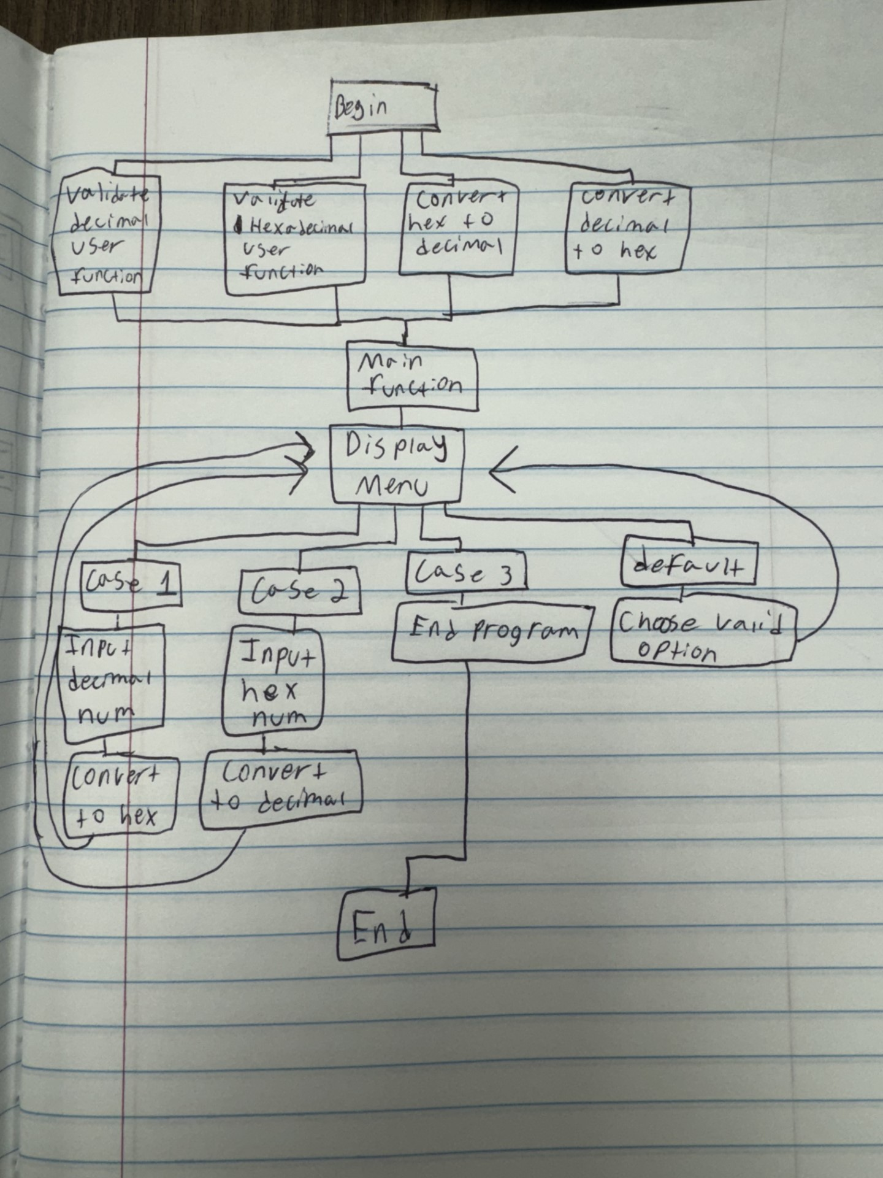

C. The code listing.

D. Screen shots showing the program in operation.

